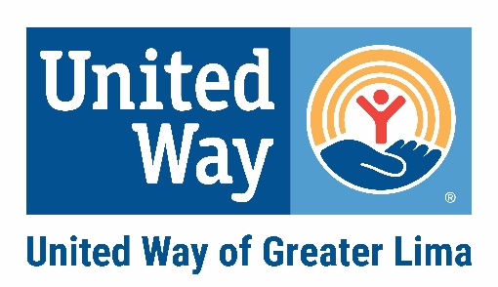
Conflict of Interest Statement
(to be signed annually)

United Way of Greater Lima, Inc.
Staff / Board of Directors / Volunteers

A conflict of interest can be considered to exist in any situation where the actions or activities of a staff member, board member or volunteer might result in improper gain or advantage to self or someone close to self, the perception of improper personal gain or advantage, or have an adverse effect on the interests of the United Way of Greater Lima.

Examples of “conflict of interest” include: doing business with relatives or friends on behalf of the organization; giving or accepting gifts or favors from a vendor or a donor; having a financial interest in a business that provides materials or services to the organization; granting employment to family members or friends; or serving on a partner agency board. On some occasions it is not clear whether a conflict exists. A good rule of thumb is to avoid even the appearance of conflict.

When a conflict/potential conflict does exist, the concern should be revealed to the appropriate party. The United Way will then come to a logical and openly communicated decision about how to handle it. The organization will treat the conflict as follows:

- United Way will fully disclose the situation to all relevant parties and make the disclosure a matter of public record.
- The person with the conflict will abstain from voting, discussion or any decision-making related to the actual or possible conflict. For example, if a board member serves on a Partner Agency board, that board member will abstain from any votes related to that Partner Agency.
- Other action as the President and/or Board of Directors deem necessary.

I have a conflict of interest in the situation explained in the space below. (If no conflict of interest exists, write “none”.)

In signing this document, I agree that I have read and understand the Conflict of Interest policy and agree to avoid or at a minimum, make known, any activity that may present a conflict in fact or in appearance, with United Way of Greater Lima. If a conflict is present, I agree to adhere to the guidelines set forth by the United Way.

Printed Name Signature Date
3-31-21

